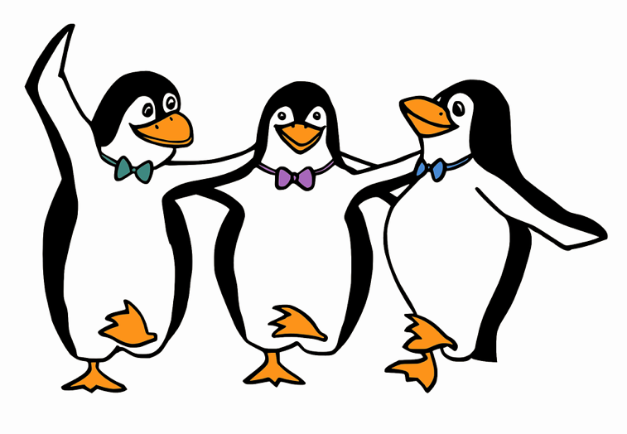
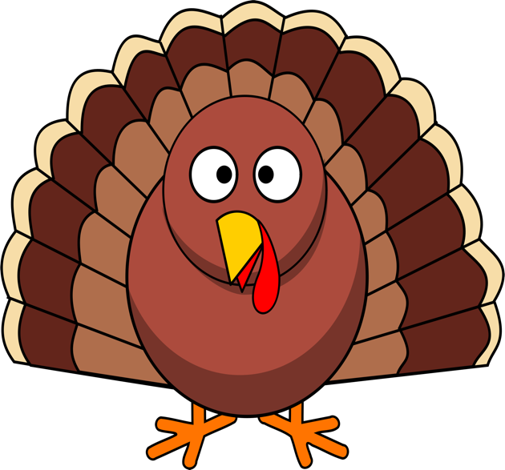

Attention Hunking Bobcats
There are 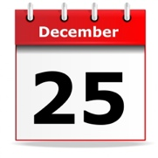days of school from

This Photo by Unknown Author is licensed under CC BY-NC

To

Winter Break
Thanksgiving Break

Come every day and be entered in a raffle
to win prizes including Amazon Gift Cards!
Prizes will be given out at school December 23
Attend Today Achieve Tomorrow

